For my first process analysis I wanted to focus on my video project from IAT 202 because it beyond most others showcases how well my team and I went from a rough draft into a more comprehensive story. At first all that we knew we wanted to do was have two sisters where one wasn’t real. That was the beginning of our story. From there, we started thinking more about how there needed to be some ability for time to pass and for the audience to get to know our characters.

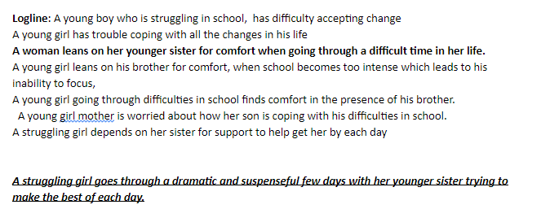

This here is our logline process and showing how we went about thinking of how to talk about our story without giving it away.

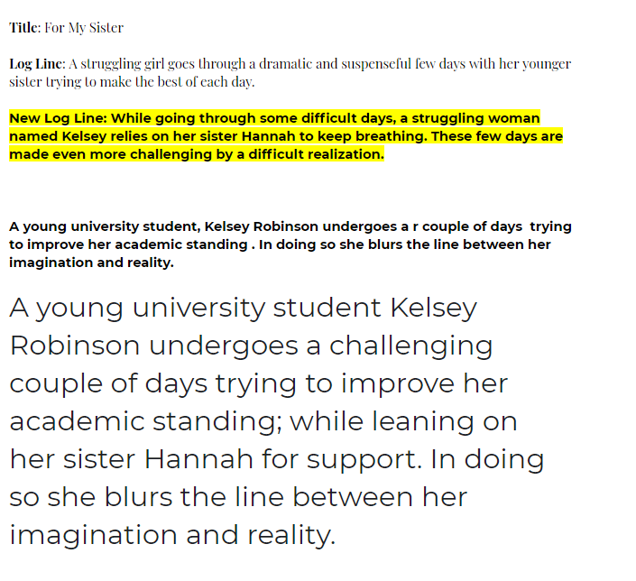

Throughout each iteration we found ourselves needing to change more and more.

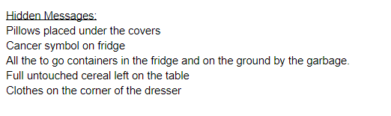

We also wanted to make sure that our audience could pick up on it without us needing to spell it out and we wanted to provide rewatchability. We did this through hidden messages throughout the film.

My role in this film was as Cinematographer and Editor mostly. One of our big references was an advert called Dear Brother. <https://www.youtube.com/watch?v=h2caT4q4Nbs>

<https://youtu.be/G-GnYmazzJw>

This right here is the first version that I uploaded of this film to my youtube channel. It is very rough and has a lot of unpolished sections.

<https://youtu.be/bchyWlRAmg8>

This is one of the next big milestones’, after this it was all about finalizing things and making sure it all looked cohesive.

<https://youtu.be/vSKmYQtAjZE>

And then here is the final version. It showcases just how much there was left to improve on that first version but yet just how much we had to learn as well about our editing skills and our narrative skills.